1. Source Code
2. Main.java

public class Main {  
 public static void main(String[] args)  
 {  
 Persegi persegi = new Persegi(23);  
 Class3D volume_persegi = new Class3D(persegi.output_luas(), 2);  
 System.*out*.println("=============");  
 System.*out*.println("persegi");  
 System.*out*.println("luas = "+persegi.output_luas());  
 System.*out*.println("=============");  
 System.*out*.println();  
  
 System.*out*.println("=============");  
 Persegi_Panjang persegi_panjang = new Persegi_Panjang(10,12);  
 System.*out*.println("persegi panjang");  
 System.*out*.println("jari - jari = " + persegi_panjang.output_luas());  
 System.*out*.println("=============");  
  
 System.*out*.println();  
 System.*out*.println("=============");  
 Lingkaran lingkaran = new Lingkaran(14);  
 System.*out*.println(" lingkaran");  
 System.*out*.println("jari - jari = " + lingkaran.Output_luas());  
 System.*out*.println("=============");  
  
 System.*out*.println();  
 System.*out*.println("=============");  
 Segitiga segitiga = new Segitiga(5,5);  
 System.*out*.println(" Segitiga");  
 System.*out*.println("jari - jari = " +segitiga.output_luas());  
 System.*out*.println("=============");  
  
 System.*out*.println();  
 System.*out*.println("=============");  
 Class3D volume_kubus = new Class3D(persegi.output_luas(), 2);  
 System.*out*.println(" Kubus");  
 volume_kubus.output_volume();  
 System.*out*.println("=============");  
  
 System.*out*.println();  
 System.*out*.println("=============");  
 Class3D volume_balok = new Class3D(persegi_panjang.output_luas(), 4);  
 System.*out*.println(" Balok");  
 volume_balok.output_volume();  
 System.*out*.println("=============");  
  
 System.*out*.println();  
 System.*out*.println("=============");  
 Class3D volume_prisma_segitiga = new Class3D(segitiga.output_luas(), 2);  
 System.*out*.println(" Prisma Segitiga");  
 volume_prisma_segitiga.output_volume();  
 System.*out*.println("=============");  
  
 System.*out*.println();  
 System.*out*.println("=============");  
 Class3D volume_Tabung = new Class3D(lingkaran.Output_luas(), 2);  
 System.*out*.println(" Tabung");  
 volume_Tabung.output_volume();  
 System.*out*.println("=============");

1. Class2D

class Persegi

{

private double sisi;

public Persegi(double Sisi)

{

this.sisi = Sisi;

}

double output_luas()

{

return this.sisi*this.sisi;

}

}

class Lingkaran

{

private double Diameter;

public Lingkaran(double diameter)

{

this.Diameter = diameter;

}

double Output_luas()

{

return this.Diameter/2;

}

}

class Persegi_Panjang

{

private double Panjang;

private double Lebar;

public Persegi_Panjang(double panjang, double lebar)

{

this.Panjang = panjang;

this.Lebar = lebar;

}

double output_luas()

{

return Panjang*Lebar;

}

}

class Segitiga

{

private double Alas;

private double Tinggi;

public Segitiga(double alas,double tinggi)

{

this.Alas = alas;

this.Tinggi = tinggi;

}

double output_luas()

{

return 0.5*this.Alas*this.Tinggi;

}

}

public class Class2D

{

}

1. Class3D

public class Class3D  
{  
 private double Luas;  
 private double Tinggi;  
  
 public Class3D(double luas, double tinggi)  
 {  
 this.Luas=luas;  
 this.Tinggi=tinggi;  
 }  
  
 void output_volume()  
 {  
 double proses = this.Luas*this.Tinggi;  
 System.*out*.println("volume = "+proses);  
 }  
}

1. Screenshot

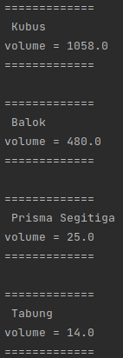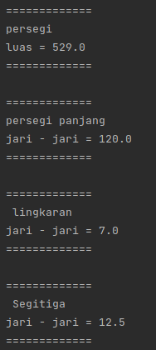

Nama : Indy Adira Khalfani

NPM : 06.2021.1.07434